Objective Questions

Q1) What is the total no. of attributes present in the data?
Ans:- There are 2 tables i.e., 1 table in the worksheet titled “Tickets” and in another worksheet titled “IT Agents”. Ticket Table has 10 attributes and IT Agents table has 4 attributes. Below is the data dictionary.

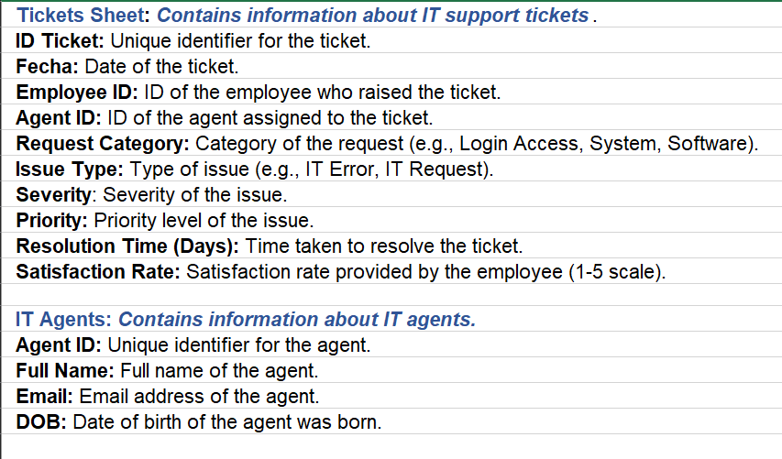

Q2) Which columns have inconsistent or missing values, and what is the count of such values?
Ans:- checked all type of inconsistent:
- Duplicate values: There is no duplicate values in the dataset. I have checked both the table
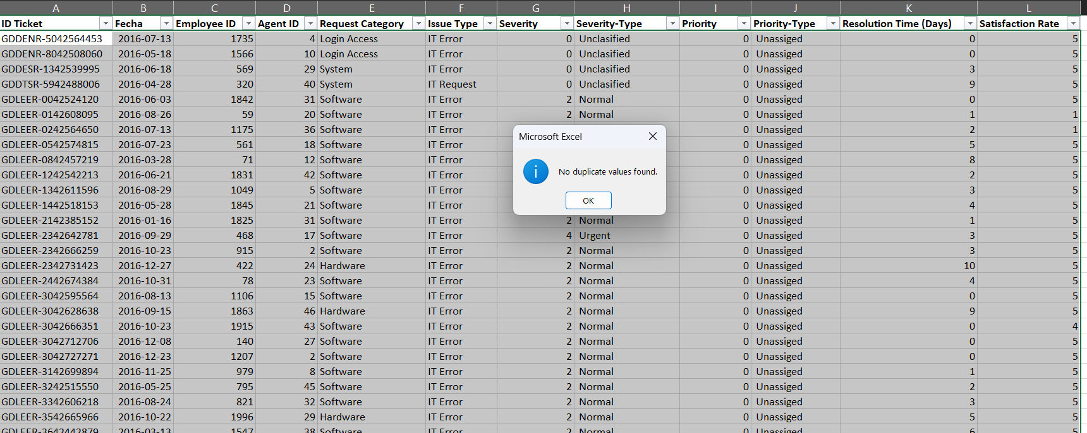
- Missing Values: There is no missing values in the dataset. I have checked with below formula,
=SUMPRODUCT(--(TRIM(Tickets!A1:L97499)="")) (for table Tickets)
=SUMPRODUCT(--(TRIM('IT Agents'!A1:D51)="")) (for table IT Agents)
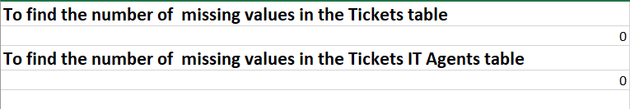
- Data format: Column fecha (date of the ticket) from the table Tickets has type of number. I have changed it to Date format(YYYY-MM-DD). Selected the column, right click and format the cell into date.
- Inconsistent column: Some column has inconsistencies like they have multiple values in a cell(Severity and priority). I have created two different column severity & severity-type and priority & priority-type. Severity and priority for numerical values and severity-type and priority-type for text values. IT Agents table has three different column for date of birth of agents. I have changed it to only one column called DOB for better calculation.
- Spelling check: The Severity-Type column contains spelling inconsistencies such as “Unclasified” (356 records) and “Mayor” (4,836 records). Similarly, the Priority-Type column contains the inconsistent label “Unassiged”, appearing in 29,410 records. We have to correct all the spellings. We can do this by using find and replace method.
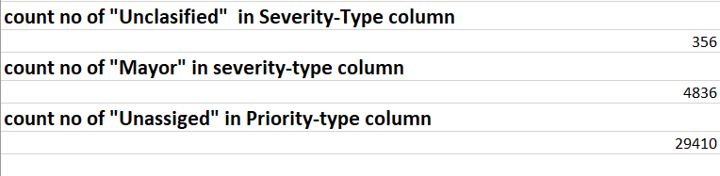
Now the Dataset is ready for analysis.

Q3) What is the average daily ticket volume over time?
Ans:- average daily ticket volume can be calculated from below formula,
Avg ticket volume = total no. of ticket / total no. of unique days
= 97498 / 1827
= 53.36
So, the average daily ticket volume is approximately 53 tickets / day
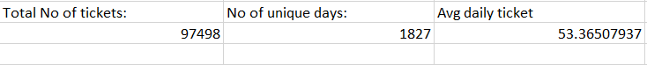

I can see from the below graph, The number of tickets is increasing every year.

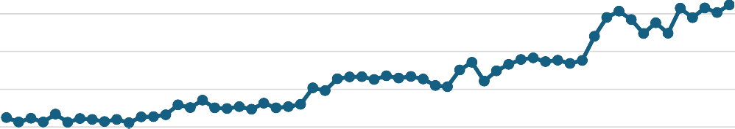
Count of daily ticket
3000
2500
2000
1500
1000
500
0
Qtr1 Qtr2 Qtr3 Qtr4 Qtr1 Qtr2 Qtr3 Qtr4 Qtr1 Qtr2 Qtr3 Qtr4 Qtr1 Qtr2 Qtr3 Qtr4 Qtr1 Qtr2 Qtr3 Qtr4 2016 2017 2018 2019 2020

Q4) What is the distribution of ticket categories (e.g., Login Access, System, Software)?
Ans: We can see from the below distribution graph and pivot table,
System has the highest(40%) and Hardware has the lowest(~10%) distribution. Login Access has the ~30% and software has ~20% distribution of total ticket.
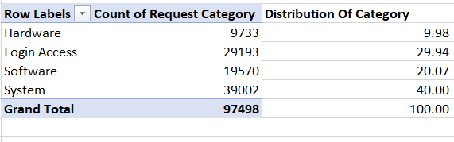

Q5) How many tickets has each agent handled?
Ans:- Below table shows the tickets handled by each agent. I have created a pivot table of agent id and count of ticket id, which shows how many tickets handled by each agent id. After that applied lookup function to fetch agent name from the IT Agent table.
Formula applied to fetch agent name: =VLOOKUP('objective questions'!E24, 'IT Agents'!A2:B51, 2)

Row Labels | Count of ticket | Agent Name
1 | 1969 | Mata Lucero
2 | 1968 | Jesus Grajeda
3 | 2021 | Elena Velez
4 | 1988 | Barraza Alberto
5 | 2000 | Willyberto Gonzales
6 | 1949 | A. Trejo
7 | 1935 | Estuardo Ocaño
8 | 1960 | Marisol Piedrahita
9 | 1949 | Velasquez Jose
10 | 1974 | Alberto Casillas
11 | 1956 | Lopez Moran.
12 | 1897 | Javier D.
13 | 1856 | Griselda Galindo
14 | 1942 | EstuardoTorres
15 | 1991 | Galindo Guadalupe
16 | 1926 | Orci Carlos
17 | 1961 | Leon Lourdes
18 | 1892 | Miller Gaviria
19 | 1984 | Alfonso Barraza
20 | 1920 | Eduardo Luna
21 | 1889 | Alberto Gastelum
22 | 1966 | Lorena
23 | 1915 | Guadalupe Hernandez
24 | 2003 | Barbara Grijalva
25 | 1906 | Sandra Lujan
26 | 1963 | Flores Sierra
27 | 1968 | Isela Leyva
28 | 1946 | Nurio Zepeda
29 | 1931 | Segura Garcia
30 | 1963 | Parra Luna
31 | 1987 | Guadalupe Torrico
32 | 1974 | Silvia Morales
33 | 1958 | Guadalupe Villanueva
34 | 1927 | Diana Rojo
35 | 2007 | Melinda
36 | 1913 | Luis Torres
37 | 1931 | Jesus Pacheco
38 | 1938 | Enrique Montiel
39 | 2026 | Jesus Contreras
40 | 1920 | Alfredo Barreras
41 | 1966 | Aldo Carrillo
42 | 1945 | Darwin E.
43 | 1897 | Reyna Santacruz
44 | 1943 | Eva Cardenas
45 | 1929 | Luis Arguello
46 | 1950 | Rosa Olguin
47 | 1933 | Yomaira Agudelo
48 | 2027 | Aurelio Tanori
49 | 1890 | Armando Sierra
50 | 1949 | Ramon Macias
Grand Total | 97498
Top 10 Agents by Ticket Volume:
  - Aurelio Tanori ( 48 ) : 2027 tickets
  - Jesus Contreras ( 39 ) : 2026 tickets
  - Elena Velez ( 3 ) : 2021 tickets
  - Melinda ( 35 ) : 2007 tickets
  - Barbara Grijalva (24 ) : 2003 tickets
  - Willyberto Gonzales ( 5 ) : 2000 tickets
  - Galindo Guadalupe (15 ) : 1991 tickets
  - Barraza Alberto ( 4 ) : 1988 tickets
  - Guadalupe Torrico ( 31 ) : 1987 tickets
  - Alfonso Barraza ( 19 ) : 1984 tickets

Q6) How can you extract the domain from the email addresses in the IT Agents sheet?
Ans I have used a combination of FIND, MID, and LEFT functions to extract the domain name from the email addresses. First, the FIND function is used to locate the position of the @ symbol in the email address. Using this position, the MID function extracts the text starting immediately after the @ symbol until the end of the email address. Next, the FIND function is applied again to identify the position of the dot (.) within the extracted text. The LEFT function then extracts only the characters before the dot. This approach accurately returns only the required domain name from the email address.
Example for email: lucero.mata@fp20analytics.com
=LEFT(MID(C2, FIND("@", C2) + 1, LEN(C2)), FIND(".", MID(C2, FIND("@", C2) + 1, LEN(C2))) - 1)
This formula will return “fp20analytics”.

Q7) How can you find the full name of an agent given their Agent ID?
Ans:- We can find the full name of agent using below formula, It will find the full name of the agent using agent id in IT_Agent table. In this formula 2 denotes the return_array_index, which is full name column. We need exact match therefore we used FALSE as a 4th value of lookup function.
=VLOOKUP(Agent_ID, IT_Agents!A:B, 2, FALSE)

Q8) What is the count of each issue type (e.g., IT Error, IT Request)?
Ans:- Below pivot table shows the count of each issue type. I have calculated this by using pivot table. Created a pivot table with issue type as a row and count of ticket id as a value.
IT Error has 24, 278 tickets and IT Request has 73, 220 tickets.

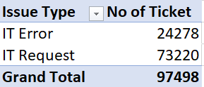


Count of issue type
IT Request
Total
IT Error
0
20000
40000
60000
80000

Q9) What is the daily average resolution time for tickets?
Ans:-
Minimum daily average resolution time: 2.5 days approximately
Maximum daily average resolution time: 7.5 days approximately
Overall daily average resolution time: 4.5 days approximately

I find this by using pivot table of fecha as row and average of resolution time as a value. It returns average of resolution time every days and grand total shows overall average resolution time.
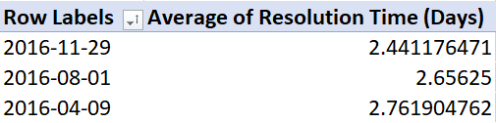
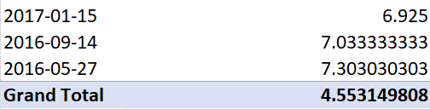

Q10) How has the volume of tickets changed over time?
Ans:- We can see from the below Pivot table and graphs, The volume of tickets shows a steady upward trend from 2016 to 2020, indicating a growing number of tickets being raised each year. while 2020 exhibits a sharp rise in the number of tickets. The line chart further confirms an increasing daily ticket trend with some fluctuations, indicating growing demand for IT support services over the years.

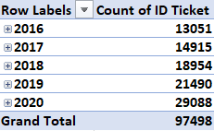

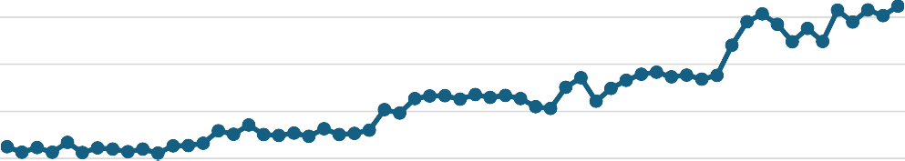
Count of daily ticket
3000
2500
2000
1500
1000
500
0
Qtr1 Qtr2 Qtr3 Qtr4 Qtr1 Qtr2 Qtr3 Qtr4 Qtr1 Qtr2 Qtr3 Qtr4 Qtr1 Qtr2 Qtr3 Qtr4 Qtr1 Qtr2 Qtr3 Qtr4 2016 2017 2018 2019 2020

Q11) What is the average age of the IT agents?
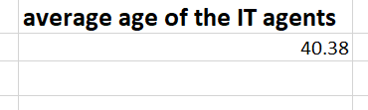
Ans:- The average age of the IT Agents is 40.38 yrs. First we find the age of the every agent using this formula, =DATEDIF(DOB, TODAY(), "Y"). After that we find the average of the total age using this formula, =AVERAGE('IT Agents'!F2:F51)

Q12) Is there a correlation between the severity of issues and the resolution time?
Ans:- We checked the correlation value b/w severity and resolution time, the value is -0.0405, it indicates a very weak negative correlation between Severity and Resolution Time (Days). But I can see in data, when the severity is urgent the maximum resolution time is 10 days.
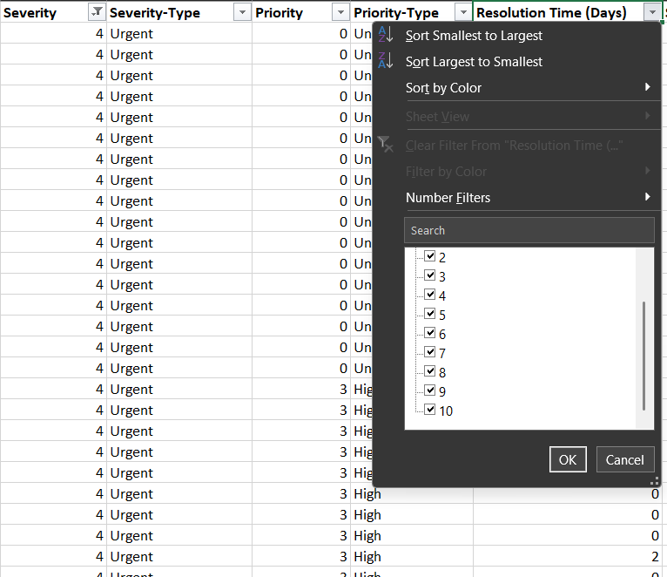
Used formula to find correlation, =CORREL(Tickets!G:G, Tickets!K:K)
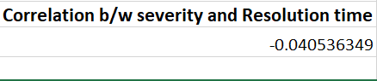

Q13) How many categorical columns are there in the data? [Search about categorical and continuous data, and try to answer this question]
Ans:-
ID Ticket ---- Categorical(Identifier) Unique ID, label not a measurement
Fecha ---- Continuous (Time-based) Date is a temporal continuous variable
Employee ID ---- Categorical(Identifier) ID, no numeric meaning
Agent ID ---- Categorical(Identifier) ID, no numeric meaning
Request Category ---- Categorical Represents request types
Issue Type ---- Categorical Represents issue types
Severity ---- Categorical(Ordinal) Ordered levels
Priority ---- Categorical(Ordinal) Ordered levels
Resolution Time (Days) ---- Continuous Measured in days
Satisfaction Rate ---- Continuous Numeric scale (1–5)
Full Name ---- Categorical (Nominal) Text label
Email ---- Categorical (Nominal) Text label
DOB ---- Continuous (Time-based) Date / time variable

Categorical variables represent labels or classifications, while continuous variables represent measurable quantities. In the given dataset, categorical columns include identifiers and descriptive attributes such as ID Ticket, Employee ID, Agent ID, Request Category, Issue Type, Severity, Priority, Full Name, and Email. Continuous columns include time-based and numeric measurements such as Fecha, Resolution Time (Days), Satisfaction Rate, and DOB.
